 | Министерство науки и высшего образования Российской Федерации Федеральное государственное автономное образовательное учреждение высшего образования «Московский государственный технический университет имени Н.Э. Баумана (национальный исследовательский университет)» (МГТУ им. Н.Э. Баумана)
ФАКУЛЬТЕТ Информатика и системы управления и искусственный интеллект
КАФЕДРА Системы обработки информации и управления

Домашнее задание №1
По курсу
«Оптимизация баз данных систем машинного обучения»
«Обнаружение функциональных зависимостей»
Вариант набора данных 19

Подготовил:
Студент группы
ИУ5-12М Пермяков Дмитрий Кириллович
04.10.2025
Проверил:
Плужникова Ольга Юрьевна

2025 г.

Задание
Для заданного набора данных
1) определите ключ с помощью алгоритма HyUCC;
2) сгенерируйте схему базы данных с таблицами в нормальной форме Бойса-Кодда с помощью алгоритма Normalize (автоматически сгенерированную схему БД можно увидеть в папке Metanome\results и в окне "Adding Context for backend");
3) представьте эту схему базы данных в нотации пакета ERwin;
4) преобразуйте схему базы данных в схему с синтетическими ключами;
5) предложите алгоритм заполнения таблиц базы данных (с синтетическими ключами) данными из вашего набора. Требования:
- записи набора данных читаются последовательно один раз,
- обращение к таблицам базы данных указывать в виде спецификаций операторов SQL.

Вариант набора данных | Имя файла (архив zip) | Имя  набора данных в архиве
19 | 43 early+stage+diabetes+risk+prediction+dataset.zip | diabetes_data_upload.csv

Это описание набора данных для предсказания риска диабета на ранних стадиях.
Age – возраст пациента (целое число).
Gender – пол (Male, Female).
Polyuria – учащённое мочеиспускание.
Polydipsia – чрезмерная жажда.
sudden weight loss – резкая потеря веса.
weakness – общая слабость.
Polyphagia – чрезмерный аппетит.
Genital thrush – грибковая инфекция половых органов.
visual blurring – нарушение зрения.
Itching – кожный зуд.
Irritability – раздражительность.
delayed healing – задержка заживления ран.
partial paresis – частичный паралич.
muscle stiffness – скованность мышц.
Alopecia – выпадение волос.
Obesity – ожирение.

Размер: 520 записей, 17 атрибутов
Цель: предсказание наличия диабета на ранних стадиях
Формат признаков:
1 числовой атрибут (Age)
15 категориальных атрибутов (ответы «Yes/No»)
1 целевая переменная (class: Positive или Negative)

Очистим дубликаты
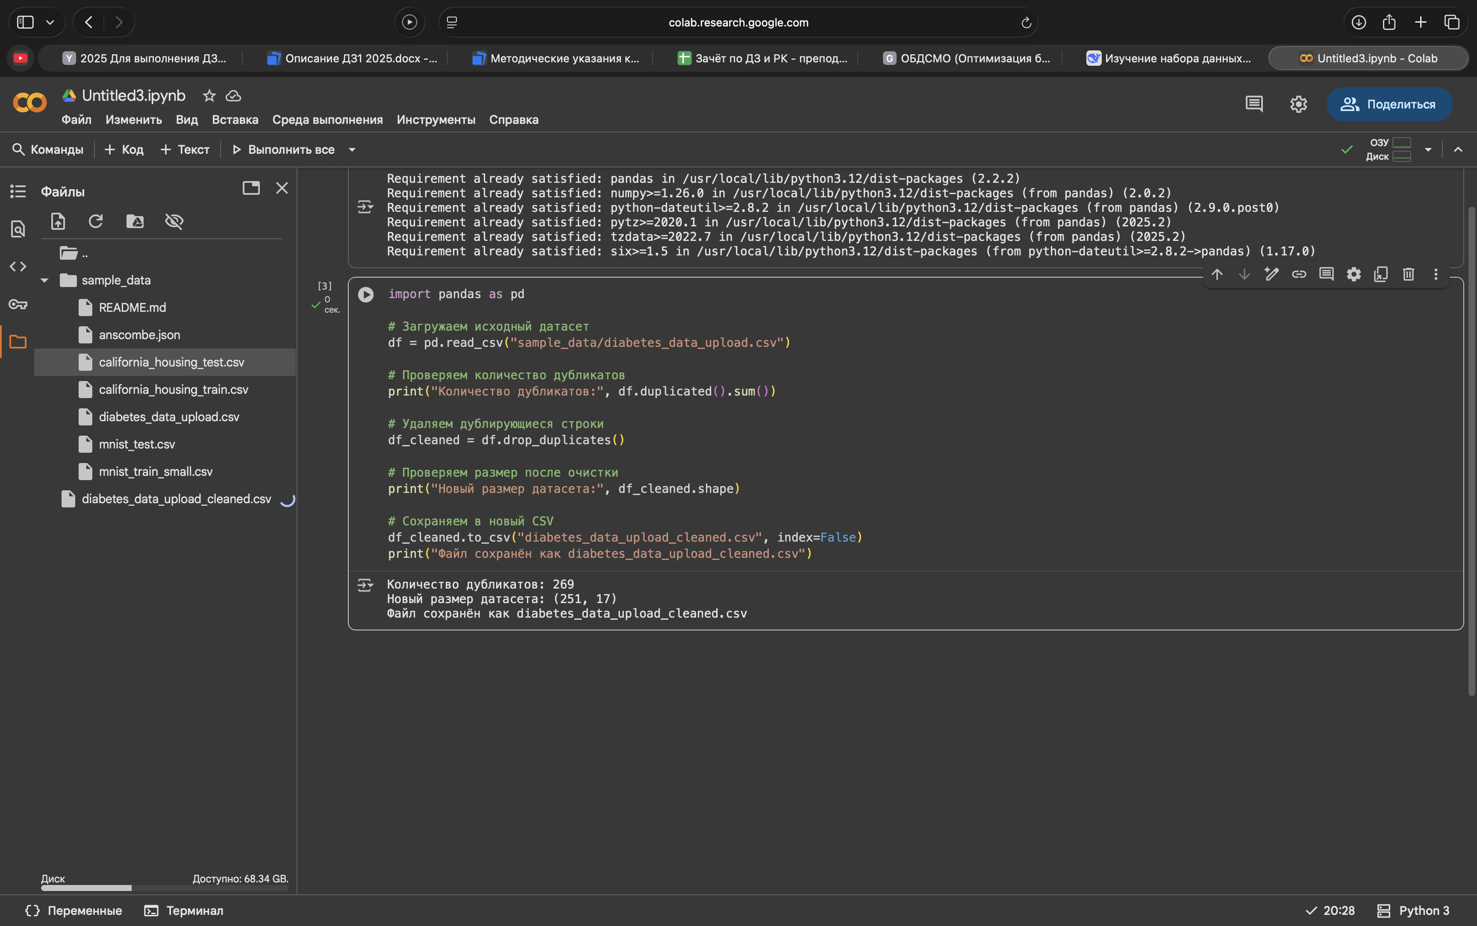

Добавим по пути Metanome\backend\WEB-INF\classes\inputData
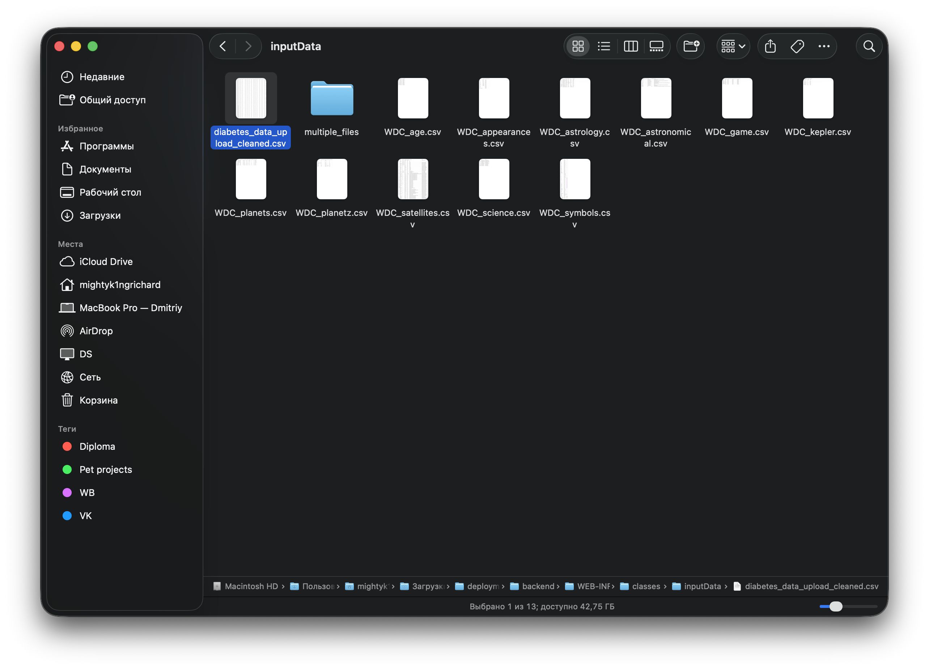
Добавил алгоритмы по пути Metanome\backend\WEB-INF\classes\algorithms
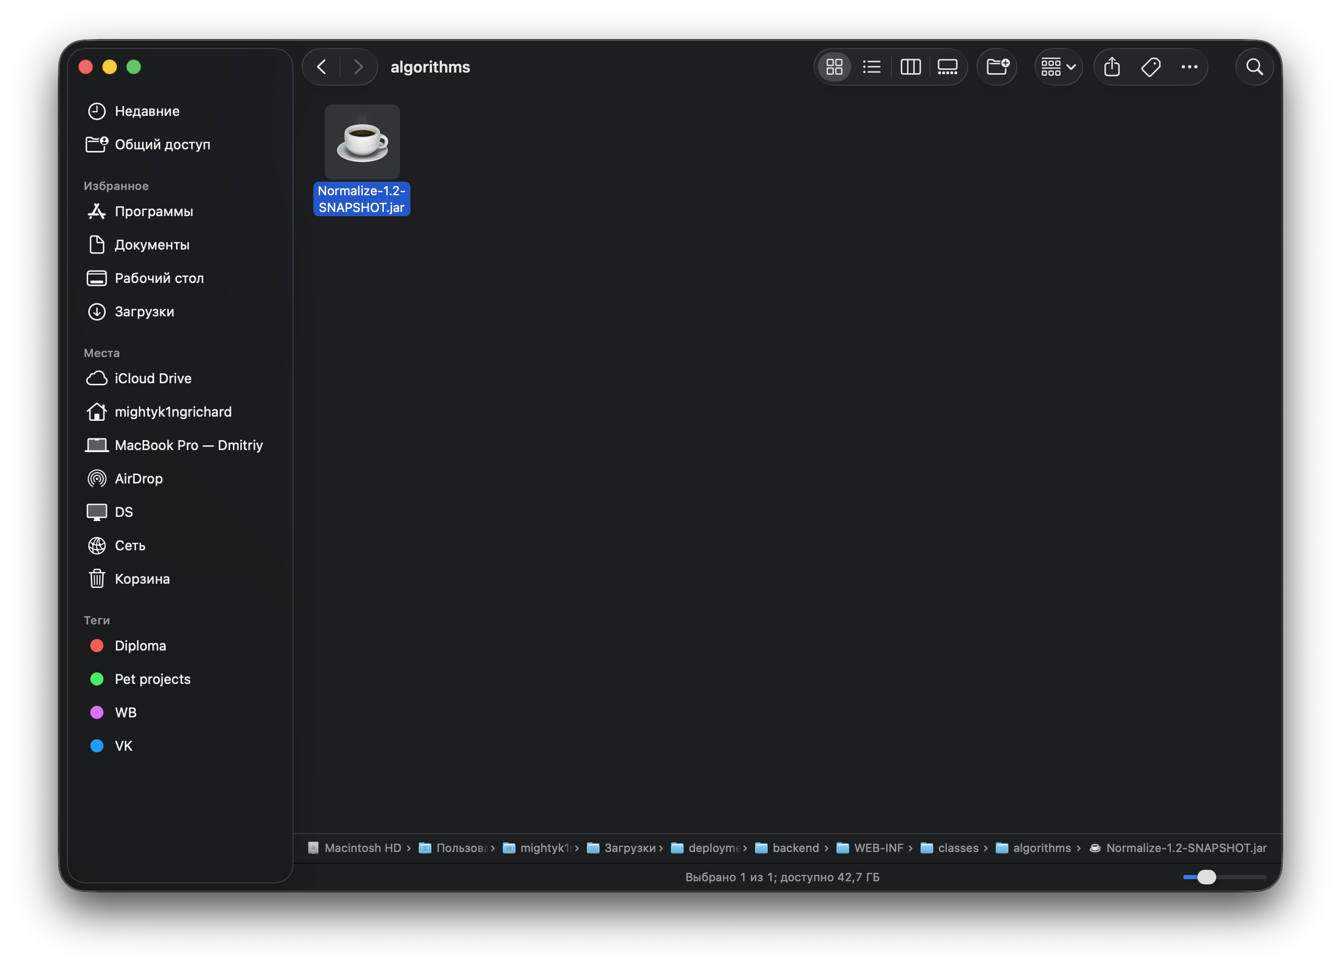
Работа с Metanome.

Запустил run.sh, открыл localhost:8080 в браузере.
Изменил настройки датасета и алгоритмов.
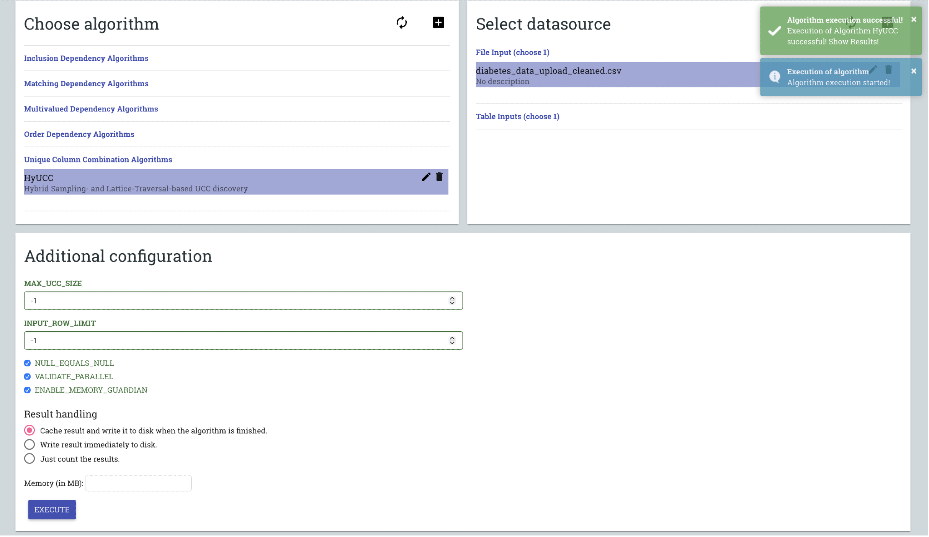

# TABLES
diabetes_data_upload_cleaned.csv 1
# COLUMN
1.Polydipsia 4
1.Polyuria 3
1.partial paresis 13
1.Age 1
1.sudden weight loss 5
1.Obesity 16
1.Irritability 11
1.class 17
1.Genital thrush 8
1.Polyphagia 7
1.visual blurring 9
1.Alopecia 15
1.weakness 6
1.Itching 10
1.delayed healing 12
1.Gender 2
1.muscle stiffness 14
# RESULTS
1,15,2,10,16,7,3,12,5,9,6
1,15,2,10,16,4,7,12,13,5,9,6
1,15,2,8,10,16,7,12,13,5,9,6
1,15,2,10,16,7,17,12,13,5,9,6

Ключи:
- {Age, Alopecia, Gender, Itching, Obesity, Polyphagia, Polyuria, delayed healing, sudden weight loss, visual blurring, weakness}
- {Age, Alopecia, Gender, Itching, Obesity, Polydipsia, Polyphagia, delayed healing, partial paresis, sudden weight loss, visual blurring, weakness}
- {Age, Alopecia, Gender, Genital thrush, Itching, Obesity, Polyphagia, delayed healing, partial paresis, sudden weight loss, visual blurring, weakness}
- {Age, Alopecia, Gender, Itching, Obesity, Polyphagia, class, delayed healing, partial paresis, sudden weight loss, visual blurring, weakness}

Минимальные по мощности – комбинации из одиннадцати атрибутов (№ 1).

Далее Normalize
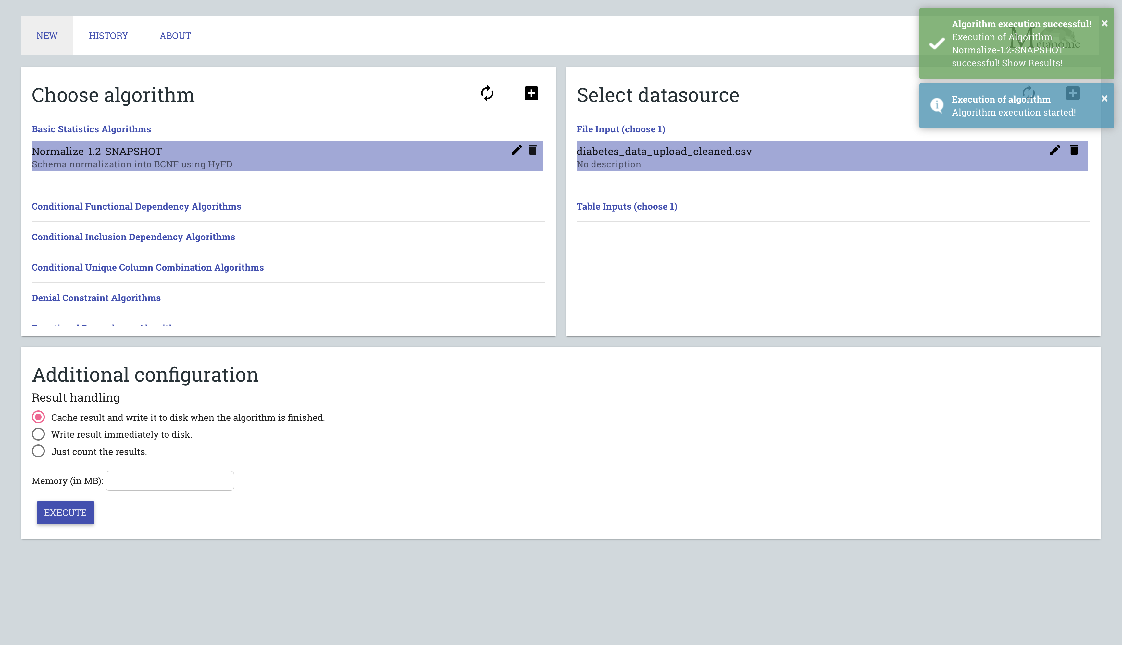

{"type":"BasicStatistic","columnCombination":{"columnIdentifiers":[{"tableIdentifier":"diabetes_data_upload_cleaned.csv","columnIdentifier":"Age"},{"tableIdentifier":"diabetes_data_upload_cleaned.csv","columnIdentifier":"Alopecia"},{"tableIdentifier":"diabetes_data_upload_cleaned.csv","columnIdentifier":"Gender"},{"tableIdentifier":"diabetes_data_upload_cleaned.csv","columnIdentifier":"Genital thrush"},{"tableIdentifier":"diabetes_data_upload_cleaned.csv","columnIdentifier":"Itching"},{"tableIdentifier":"diabetes_data_upload_cleaned.csv","columnIdentifier":"Obesity"},{"tableIdentifier":"diabetes_data_upload_cleaned.csv","columnIdentifier":"Polyphagia"},{"tableIdentifier":"diabetes_data_upload_cleaned.csv","columnIdentifier":"Polyuria"},{"tableIdentifier":"diabetes_data_upload_cleaned.csv","columnIdentifier":"delayed healing"},{"tableIdentifier":"diabetes_data_upload_cleaned.csv","columnIdentifier":"partial paresis"},{"tableIdentifier":"diabetes_data_upload_cleaned.csv","columnIdentifier":"sudden weight loss"},{"tableIdentifier":"diabetes_data_upload_cleaned.csv","columnIdentifier":"visual blurring"},{"tableIdentifier":"diabetes_data_upload_cleaned.csv","columnIdentifier":"weakness"}]},"statisticMap":{"ForeignKey":{"type":"BasicStatisticValueString","value":"diabetes_data_upload_cleaned.csv.Age, diabetes_data_upload_cleaned.csv.Polyuria, diabetes_data_upload_cleaned.csv.sudden weight loss, diabetes_data_upload_cleaned.csv.weakness, diabetes_data_upload_cleaned.csv.visual blurring, diabetes_data_upload_cleaned.csv.Itching, diabetes_data_upload_cleaned.csv.delayed healing, diabetes_data_upload_cleaned.csv.partial paresis, diabetes_data_upload_cleaned.csv.Alopecia"},"PrimaryKey":{"type":"BasicStatisticValueString","value":"diabetes_data_upload_cleaned.csv.Age, diabetes_data_upload_cleaned.csv.Gender, diabetes_data_upload_cleaned.csv.Polyuria, diabetes_data_upload_cleaned.csv.sudden weight loss, diabetes_data_upload_cleaned.csv.weakness, diabetes_data_upload_cleaned.csv.Polyphagia, diabetes_data_upload_cleaned.csv.Genital thrush, diabetes_data_upload_cleaned.csv.visual blurring, diabetes_data_upload_cleaned.csv.Itching, diabetes_data_upload_cleaned.csv.delayed healing, diabetes_data_upload_cleaned.csv.Alopecia, diabetes_data_upload_cleaned.csv.Obesity"}}}
{"type":"BasicStatistic","columnCombination":{"columnIdentifiers":[{"tableIdentifier":"diabetes_data_upload_cleaned.csv","columnIdentifier":"Age"},{"tableIdentifier":"diabetes_data_upload_cleaned.csv","columnIdentifier":"Alopecia"},{"tableIdentifier":"diabetes_data_upload_cleaned.csv","columnIdentifier":"Irritability"},{"tableIdentifier":"diabetes_data_upload_cleaned.csv","columnIdentifier":"Itching"},{"tableIdentifier":"diabetes_data_upload_cleaned.csv","columnIdentifier":"Polyuria"},{"tableIdentifier":"diabetes_data_upload_cleaned.csv","columnIdentifier":"delayed healing"},{"tableIdentifier":"diabetes_data_upload_cleaned.csv","columnIdentifier":"partial paresis"},{"tableIdentifier":"diabetes_data_upload_cleaned.csv","columnIdentifier":"sudden weight loss"},{"tableIdentifier":"diabetes_data_upload_cleaned.csv","columnIdentifier":"visual blurring"},{"tableIdentifier":"diabetes_data_upload_cleaned.csv","columnIdentifier":"weakness"}]},"statisticMap":{"PrimaryKey":{"type":"BasicStatisticValueString","value":"diabetes_data_upload_cleaned.csv.Age, diabetes_data_upload_cleaned.csv.Polyuria, diabetes_data_upload_cleaned.csv.sudden weight loss, diabetes_data_upload_cleaned.csv.weakness, diabetes_data_upload_cleaned.csv.visual blurring, diabetes_data_upload_cleaned.csv.Itching, diabetes_data_upload_cleaned.csv.delayed healing, diabetes_data_upload_cleaned.csv.partial paresis, diabetes_data_upload_cleaned.csv.Alopecia"}}}
{"type":"BasicStatistic","columnCombination":{"columnIdentifiers":[{"tableIdentifier":"diabetes_data_upload_cleaned.csv","columnIdentifier":"Age"},{"tableIdentifier":"diabetes_data_upload_cleaned.csv","columnIdentifier":"Gender"},{"tableIdentifier":"diabetes_data_upload_cleaned.csv","columnIdentifier":"Genital thrush"},{"tableIdentifier":"diabetes_data_upload_cleaned.csv","columnIdentifier":"Itching"},{"tableIdentifier":"diabetes_data_upload_cleaned.csv","columnIdentifier":"Polydipsia"},{"tableIdentifier":"diabetes_data_upload_cleaned.csv","columnIdentifier":"Polyphagia"},{"tableIdentifier":"diabetes_data_upload_cleaned.csv","columnIdentifier":"Polyuria"},{"tableIdentifier":"diabetes_data_upload_cleaned.csv","columnIdentifier":"sudden weight loss"},{"tableIdentifier":"diabetes_data_upload_cleaned.csv","columnIdentifier":"visual blurring"},{"tableIdentifier":"diabetes_data_upload_cleaned.csv","columnIdentifier":"weakness"}]},"statisticMap":{"ForeignKey":{"type":"BasicStatisticValueString","value":"diabetes_data_upload_cleaned.csv.Age, diabetes_data_upload_cleaned.csv.Gender, diabetes_data_upload_cleaned.csv.Polyuria, diabetes_data_upload_cleaned.csv.Polydipsia, diabetes_data_upload_cleaned.csv.sudden weight loss, diabetes_data_upload_cleaned.csv.weakness, diabetes_data_upload_cleaned.csv.Polyphagia, diabetes_data_upload_cleaned.csv.Genital thrush, diabetes_data_upload_cleaned.csv.visual blurring"},"PrimaryKey":{"type":"BasicStatisticValueString","value":"diabetes_data_upload_cleaned.csv.Age, diabetes_data_upload_cleaned.csv.Gender, diabetes_data_upload_cleaned.csv.Polyuria, diabetes_data_upload_cleaned.csv.sudden weight loss, diabetes_data_upload_cleaned.csv.weakness, diabetes_data_upload_cleaned.csv.Polyphagia, diabetes_data_upload_cleaned.csv.Genital thrush, diabetes_data_upload_cleaned.csv.visual blurring, diabetes_data_upload_cleaned.csv.Itching"}}}
{"type":"BasicStatistic","columnCombination":{"columnIdentifiers":[{"tableIdentifier":"diabetes_data_upload_cleaned.csv","columnIdentifier":"Age"},{"tableIdentifier":"diabetes_data_upload_cleaned.csv","columnIdentifier":"Gender"},{"tableIdentifier":"diabetes_data_upload_cleaned.csv","columnIdentifier":"Genital thrush"},{"tableIdentifier":"diabetes_data_upload_cleaned.csv","columnIdentifier":"Polydipsia"},{"tableIdentifier":"diabetes_data_upload_cleaned.csv","columnIdentifier":"Polyphagia"},{"tableIdentifier":"diabetes_data_upload_cleaned.csv","columnIdentifier":"Polyuria"},{"tableIdentifier":"diabetes_data_upload_cleaned.csv","columnIdentifier":"muscle stiffness"},{"tableIdentifier":"diabetes_data_upload_cleaned.csv","columnIdentifier":"sudden weight loss"},{"tableIdentifier":"diabetes_data_upload_cleaned.csv","columnIdentifier":"visual blurring"},{"tableIdentifier":"diabetes_data_upload_cleaned.csv","columnIdentifier":"weakness"}]},"statisticMap":{"ForeignKey":{"type":"BasicStatisticValueString","value":"diabetes_data_upload_cleaned.csv.Age, diabetes_data_upload_cleaned.csv.Gender, diabetes_data_upload_cleaned.csv.Polydipsia, diabetes_data_upload_cleaned.csv.sudden weight loss, diabetes_data_upload_cleaned.csv.weakness, diabetes_data_upload_cleaned.csv.Polyphagia, diabetes_data_upload_cleaned.csv.Genital thrush, diabetes_data_upload_cleaned.csv.visual blurring"},"PrimaryKey":{"type":"BasicStatisticValueString","value":"diabetes_data_upload_cleaned.csv.Age, diabetes_data_upload_cleaned.csv.Gender, diabetes_data_upload_cleaned.csv.Polyuria, diabetes_data_upload_cleaned.csv.Polydipsia, diabetes_data_upload_cleaned.csv.sudden weight loss, diabetes_data_upload_cleaned.csv.weakness, diabetes_data_upload_cleaned.csv.Polyphagia, diabetes_data_upload_cleaned.csv.Genital thrush, diabetes_data_upload_cleaned.csv.visual blurring"}}}
{"type":"BasicStatistic","columnCombination":{"columnIdentifiers":[{"tableIdentifier":"diabetes_data_upload_cleaned.csv","columnIdentifier":"Age"},{"tableIdentifier":"diabetes_data_upload_cleaned.csv","columnIdentifier":"Gender"},{"tableIdentifier":"diabetes_data_upload_cleaned.csv","columnIdentifier":"Genital thrush"},{"tableIdentifier":"diabetes_data_upload_cleaned.csv","columnIdentifier":"Polydipsia"},{"tableIdentifier":"diabetes_data_upload_cleaned.csv","columnIdentifier":"Polyphagia"},{"tableIdentifier":"diabetes_data_upload_cleaned.csv","columnIdentifier":"class"},{"tableIdentifier":"diabetes_data_upload_cleaned.csv","columnIdentifier":"sudden weight loss"},{"tableIdentifier":"diabetes_data_upload_cleaned.csv","columnIdentifier":"visual blurring"},{"tableIdentifier":"diabetes_data_upload_cleaned.csv","columnIdentifier":"weakness"}]},"statisticMap":{"PrimaryKey":{"type":"BasicStatisticValueString","value":"diabetes_data_upload_cleaned.csv.Age, diabetes_data_upload_cleaned.csv.Gender, diabetes_data_upload_cleaned.csv.Polydipsia, diabetes_data_upload_cleaned.csv.sudden weight loss, diabetes_data_upload_cleaned.csv.weakness, diabetes_data_upload_cleaned.csv.Polyphagia, diabetes_data_upload_cleaned.csv.Genital thrush, diabetes_data_upload_cleaned.csv.visual blurring"}}}

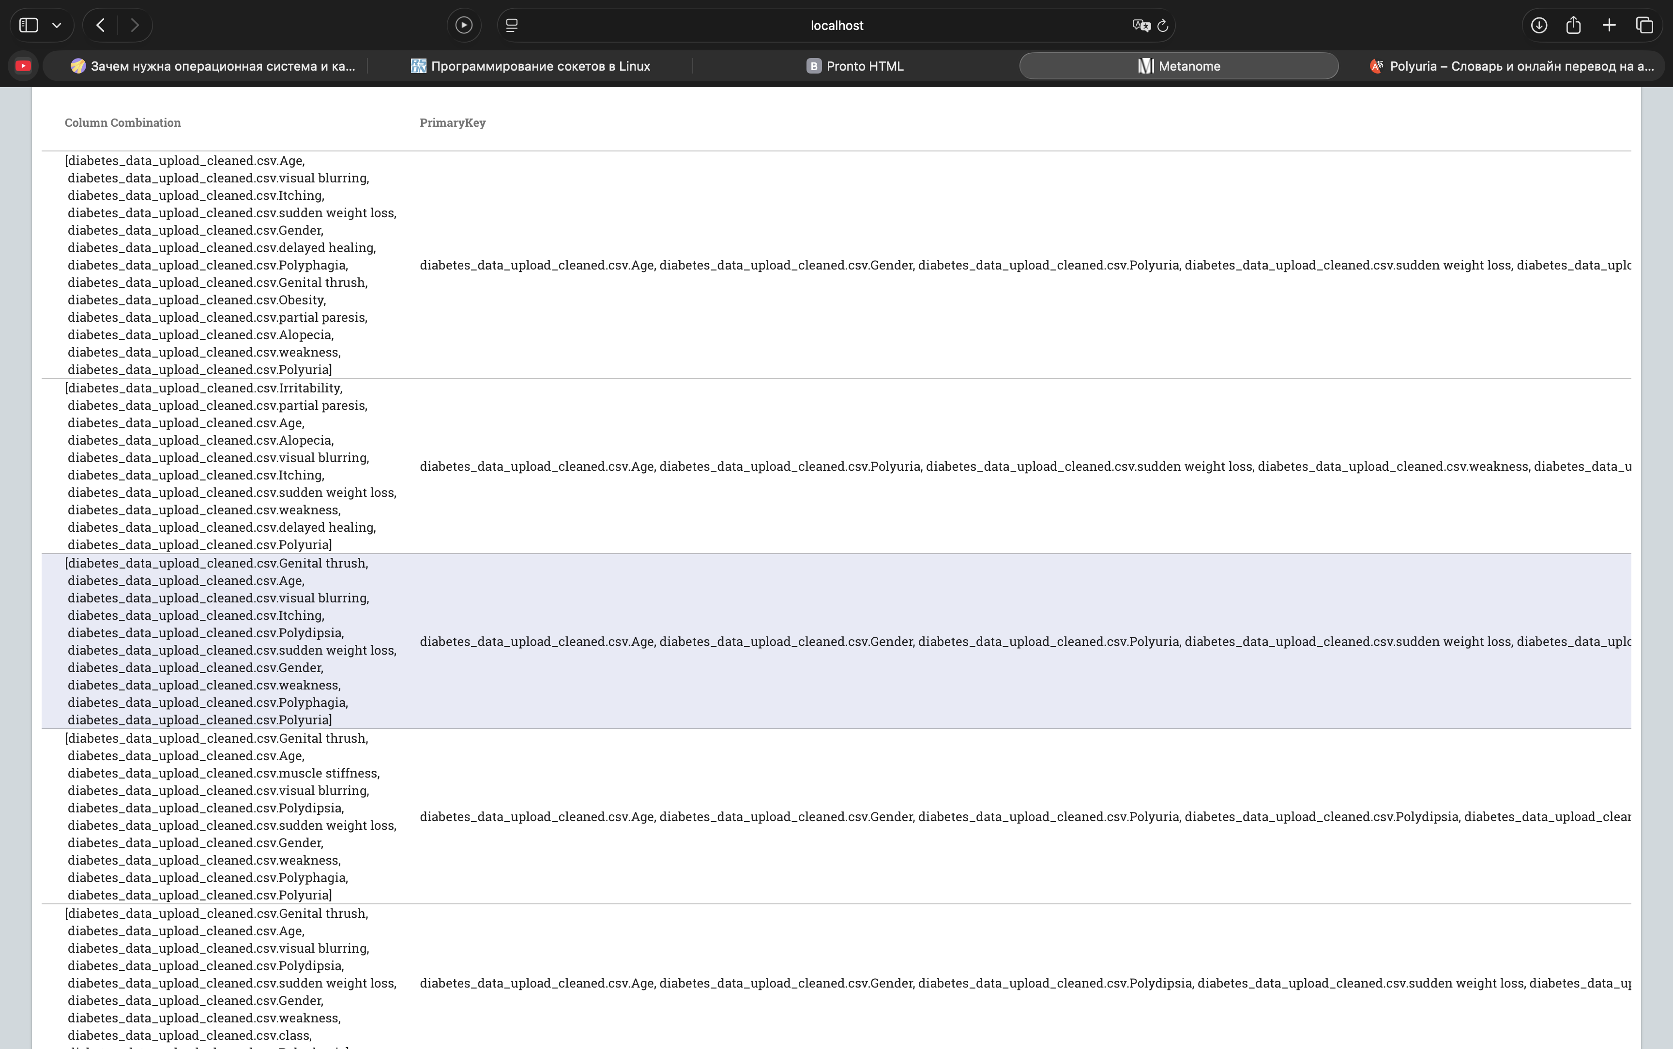

Запись в консоли
Decomposition is complete. We now need to find good primary keys for relations without a primary key.

[AGE, GENDER, POLYURIA, SUDDEN WEIGHT LOSS, WEAKNESS, POLYPHAGIA, GENITAL THRUSH, VISUAL BLURRING, ITCHING, DELAYED HEALING, partial paresis, ALOPECIA, OBESITY]
[AGE, POLYURIA, SUDDEN WEIGHT LOSS, WEAKNESS, VISUAL BLURRING, ITCHING, Irritability, DELAYED HEALING, PARTIAL PARESIS, ALOPECIA]
[AGE, GENDER, POLYURIA, Polydipsia, SUDDEN WEIGHT LOSS, WEAKNESS, POLYPHAGIA, GENITAL THRUSH, VISUAL BLURRING, ITCHING]
[AGE, GENDER, POLYURIA, POLYDIPSIA, SUDDEN WEIGHT LOSS, WEAKNESS, POLYPHAGIA, GENITAL THRUSH, VISUAL BLURRING, muscle stiffness]
[AGE, GENDER, POLYDIPSIA, SUDDEN WEIGHT LOSS, WEAKNESS, POLYPHAGIA, GENITAL THRUSH, VISUAL BLURRING, class]

В процессе нормализации было выявлено 5 отношений (таблиц) с различными комбинациями атрибутов. Это говорит о том, что система нашла функциональные зависимости и выполнила декомпозицию исходных данные

Ключи:
- {Age, Alopecia, Gender, Itching, Obesity, Polyphagia, Polyuria, delayed healing, sudden weight loss, visual blurring, weakness}
- {Age, Alopecia, Gender, Itching, Obesity, Polydipsia, Polyphagia, delayed healing, partial paresis, sudden weight loss, visual blurring, weakness}
- {Age, Alopecia, Gender, Genital thrush, Itching, Obesity, Polyphagia, delayed healing, partial paresis, sudden weight loss, visual blurring, weakness}
- {Age, Alopecia, Gender, Itching, Obesity, Polyphagia, class, delayed healing, partial paresis, sudden weight loss, visual blurring, weakness}

[AGE, GENDER, POLYURIA, SUDDEN WEIGHT LOSS, WEAKNESS, POLYPHAGIA, GENITAL THRUSH, VISUAL BLURRING, ITCHING, DELAYED HEALING, partial paresis, ALOPECIA, OBESITY]
[AGE, POLYURIA, SUDDEN WEIGHT LOSS, WEAKNESS, VISUAL BLURRING, ITCHING, Irritability, DELAYED HEALING, PARTIAL PARESIS, ALOPECIA]
[AGE, GENDER, POLYURIA, Polydipsia, SUDDEN WEIGHT LOSS, WEAKNESS, POLYPHAGIA, GENITAL THRUSH, VISUAL BLURRING, ITCHING]
[AGE, GENDER, POLYURIA, POLYDIPSIA, SUDDEN WEIGHT LOSS, WEAKNESS, POLYPHAGIA, GENITAL THRUSH, VISUAL BLURRING, muscle stiffness]
[AGE, GENDER, POLYDIPSIA, SUDDEN WEIGHT LOSS, WEAKNESS, POLYPHAGIA, GENITAL THRUSH, VISUAL BLURRING, class]

Схема ERWin:
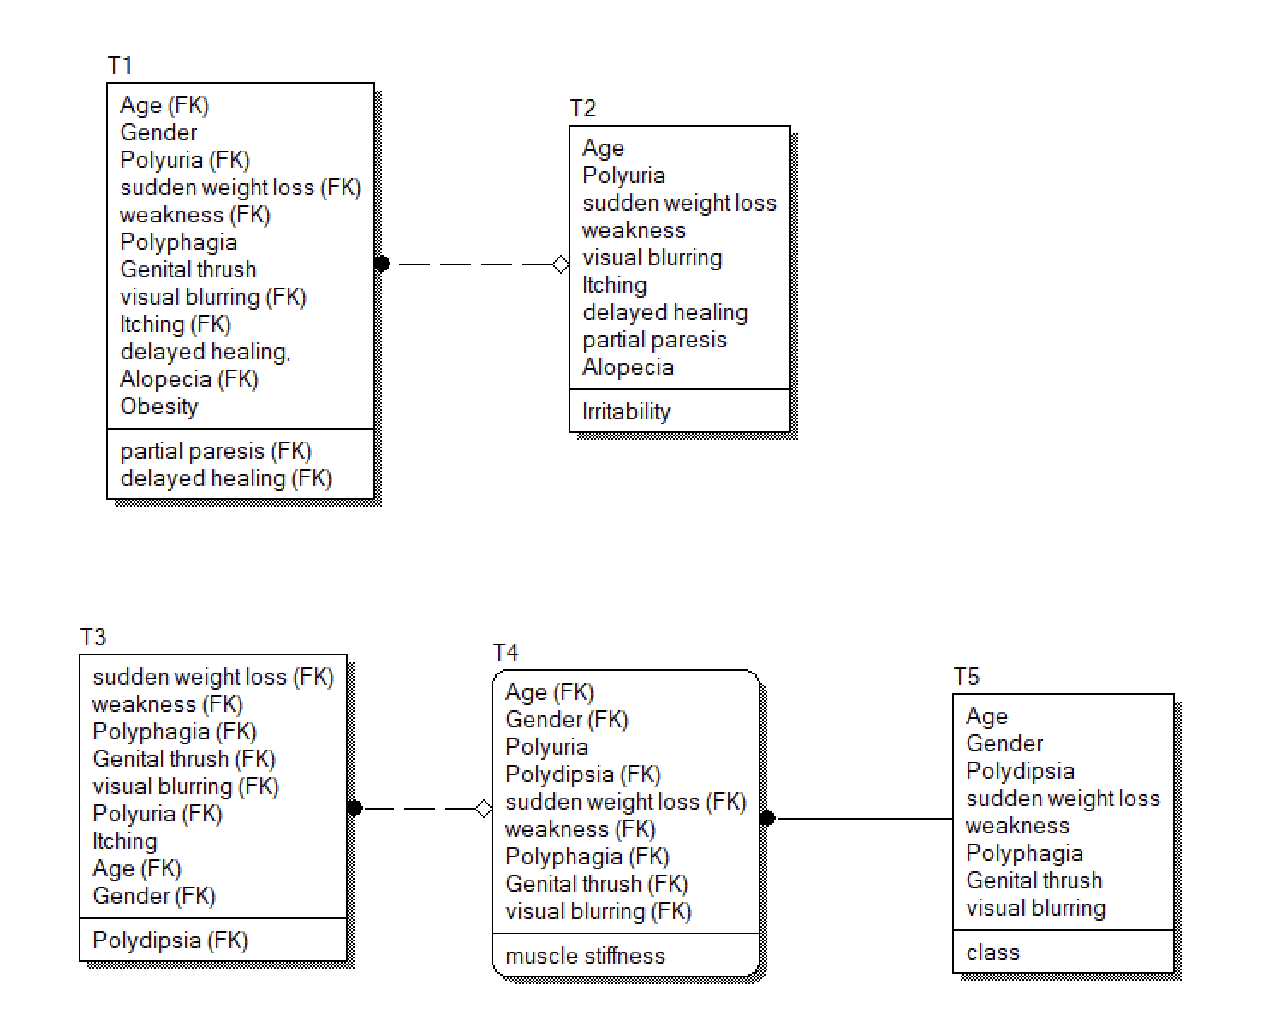
Схема с синтетическим ключом В БД создавалась бы так:
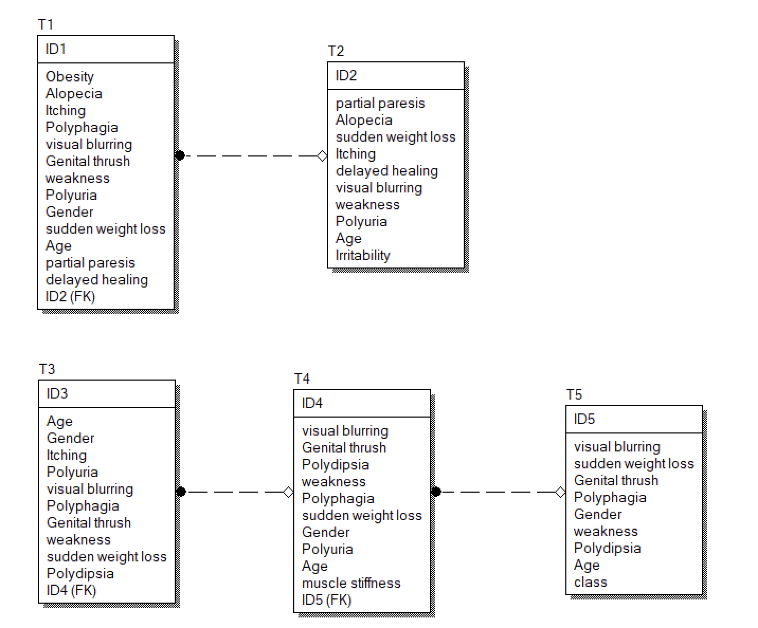

Алгоритм заполнения таблиц базы данных данными из набора

Опеределим порядок заполнения таблиц: T2, T1, T5, T4, T3

Получаем на вход строку из датасета:
{Age, Gender, Polyuria, Polydipsia, sudden_weight_loss, weakness, Polyphagia, Genital_thrush, visual blurring, Itching, Irritability, delayed_healing, partial_paresis, muscle_stiffness, Alopecia, Obesity, class}

- T2
{

SELECT id FROM T2 WHERE T2.partial_paresis = partial_paresis AND T2.Alopecia = Alopecia AND T2.sudden_weight_loss = sudden_weight_loss AND T2.Itching = Itching AND T2.delayed_healing = delayed_healing AND T2.visual_blurring = visual_blurring AND T2.weakness = weakness AND T2.Polyuria = Polyuria AND T2.Age = Age AND T2.Irritability = Irritability

Результаты запишем в t2_id.

Если t2_id == NULL, то:

INSERT INTO T2 (partial_paresis, Alopecia, sudden_weight_loss, Itching, delayed_healing, visual_blurring, weakness, Polyuria, Age, Irritability)
VALUES (partial_paresis, Alopecia, sudden_weight_loss, Itching, delayed_healing, visual_blurring, weakness, Polyuria, Age, Irritability);

Переход к следующей таблице;

Иначе:
Переход к следующей таблице;

}

- T1

{

SELECT T1.Obesity = Obesity AND T1.Alopecia = Alopecia AND T1.delayed_healing = delayed_healing AND T1.Itching = Itching AND T1.Polyphagia = Polyphagia AND T1.visual_blurring = visual_blurring AND T1.Genital_thrush = Genital_thrush AND T1.weakness = weakness AND T1.Polyuria = Polyuria AND T1.Gender = Gender AND T1.sudden_weight_loss = sudden_weight_loss AND T1.Age = Age AND T1.partial_paresis = partial_paresis AND T1.ID2 = t2_id
FROM T1;

Если результат запроса NULL, то:
INSERT INTO T1 (Obesity, Alopecia, delayed_healing, Itching, Polyphagia, visual_blurring, Genital_thrush, weakness, Polyuria, Gender, sudden_weight_loss, Age, partial_paresis, ID2)
VALUES (Obesity, Alopecia, delayed_healing, Itching, Polyphagia, visual_blurring, Genital_thrush, weakness, Polyuria, Gender, sudden_weight_loss, Age, partial_paresis, t2_id);

Переход к следующей таблице;

Иначе:
Переход к следующей таблице;

}

- T5

{

SELECT T5.visual_blurring = visual_blurring AND T5.sudden_weight_loss = sudden_weight_loss AND T5.Genital_thrush = Genital_thrush AND T5.Polyphagia = Polyphagia AND T5.Gender = Gender AND T5.weakness = weakness AND T5.Polydipsia = Polydipsia AND T5.Age = Age AND T5.class = class
FROM T5;

Результат назовём t5_id.

Если t5_id == NULL, то:
INSERT INTO T5 (visual_blurring, sudden_weight_loss, Genital_thrush, Polyphagia, Gender, weakness, Polydipsia, Age, class)
VALUES (visual_blurring, sudden_weight_loss, Genital_thrush, Polyphagia, Gender, weakness, Polydipsia, Age, class);

Переход к следующей таблице

Иначе:
Переход к следующей таблице;

}

- T4

{

SELECT T4.visual_blurring = visual_blurring AND T4.Genital_thrush = Genital_thrush AND T4.Polydipsia = Polydipsia AND T4.weakness = weakness AND T4.Polyphagia = Polyphagia AND T4.sudden_weight_loss = sudden_weight_loss AND T4.Gender = Gender AND T4.Polyuria = Polyuria AND T4.Age = Age AND T4.muscle_stiffness = muscle_stiffness AND T4.ID5 = t5_id FROM T4;

Результат назовём t4_id.

Если t4_id == NULL, то:

INSERT INTO T4 (visual_blurring, Genital_thrush, Polydipsia, weakness, Polyphagia, sudden_weight_loss, Gender, Polyuria, Age, muscle_stiffness, ID5)
VALUES (visual_blurring, Genital_thrush, Polydipsia, weakness, Polyphagia, sudden_weight_loss, Gender, Polyuria, Age, muscle_stiffness, t5_id);

Переход к следующей таблице

Иначе:
Переход к следующей таблице;
}

- T3

{
SELECT T3.Age = Age AND T3.Gender = Gender AND T3.Itching = Itching AND T3.Polyuria = Polyuria AND T3.visual_blurring = visual_blurring AND T3.Polyphagia = Polyphagia AND T3.Genital_thrush = Genital_thrush AND T3.weakness = weakness AND T3.sudden_weight_loss = sudden_weight_loss AND T3.Polydipsia = Polydipsia AND T3.ID4 = t4_id FROM T3;

Результат назовём t3_id.

Если t3_id == NULL, то:
INSERT INTO T3 (Age, Gender, Itching, Polyuria, visual_blurring, Polyphagia, Genital_thrush, weakness, sudden_weight_loss, Polydipsia, ID4)
VALUES (Age, Gender, Itching, Polyuria, visual_blurring, Polyphagia, Genital_thrush, weakness, sudden_weight_loss, Polydipsia, ID4);

Конец итерации. Возвращаемся к Т1 для новой строки;

Иначе:
Конец итерации. Возвращаемся к Т1 для новой строки;
}

